**1**.**Define a class ‘product’ with data members pcode, pname and price. Create 3 objects of the class and find the product having the lowest price.**

**class Product { int pcode; string pname; double price;**

**public Product(int pcode, String pname, double**

**price) { this.pcode = pcode;**

**this.pname =**

**pname;**

**this.price = price;**

**}**

**}**

**public Product(int pcode, String pname, double**

**price) { this.pcode = pcode;**

**this.pname =**

**pname;**

**this.price = price;**

**} }**

**public class Main1 {**

**public static void main(String[] args) {**

**System.out.println("Gayathri Suresh \n 23MCA028 \n 13-feb-2024");**

**Product p1 = new Product(1, "product1", 100);**

**Product p2 = new Product(2, "product2",150);**

**Product p3 = new Product(3, "Product3", 70); Product cheapestProduct = p1; if (p2.price < cheapestProduct.price) { cheapestProduct = p3;**

**}**

**if (p3.price < cheapestProduct.price) { cheapestProduct = p3;**

**}**

System.out.println("The product with the lowest price is " + cheapestProduct.pname + " with a price of" + cheapestProduct.price);

}

}

# output

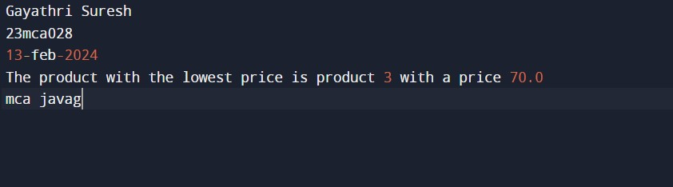

**2. Read 2 matrices from the console and perform matrix addition.**

# Code

import java.util.Scanner; public class MatrixAddition { public static void main(String[]

args) {

System.out.println("Gayathri Suresh \n 23MCA028 \n 13-feb-2024");

Scanner scanner = new Scanner(System.in); System.out.print("Enter the number of rows: "); int rows = scanner.nextInt();

System.out.print("Enter the number of columns: ");

int cols = scanner.nextInt(); int[][] matrix1 = new int[rows][cols];

System.out.println("Enter the values for matrix 1:"); for (int i = 0; i <

rows; i++) { for (int j = 0; j < cols; j++) {

matrix1[i][j] = scanner.nextInt();

}

}

int[][] matrix2 = new int[rows][cols];

System.out.println("Enter the values for matrix 2:"); for (int i = 0; i <

rows; i++) { for (int j = 0; j < cols; j++) {

matrix2[i][j] = scanner.nextInt();

}

}

int[][] result = new int[rows][cols]; for (int i = 0; i < rows; i++) { for (int j = 0; j < cols; j++) {

result[i][j] = matrix1[i][j] + matrix2[i][j];

}

}

System.out.println("R

esults:"); for (int i = 0; i < rows; i++) { for (int j = 0; j < rows; j++) {

System.out.print(resu lt[i][j] + " ");

}

System.out.println();

}

scanner.close();

}

}

# Output

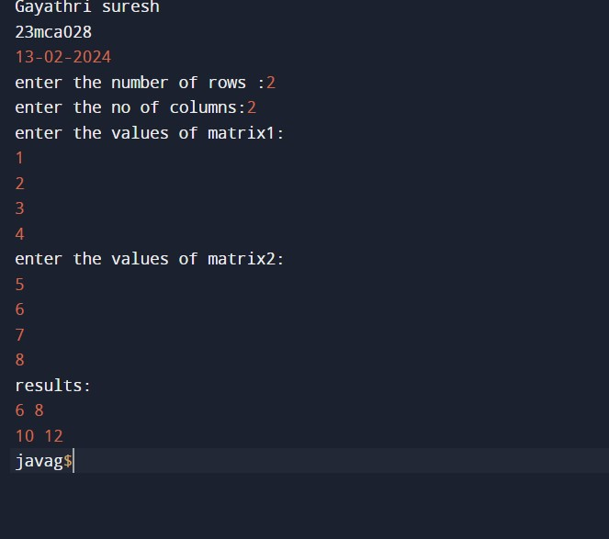

**3. Add complex numbers**  **Code**

public class

ComplexNumber { private double real; private

double imaginary;

public ComplexNumber(double real, double imaginary) { this.real = real; this.imaginary = imaginary;

}

public ComplexNumber

add(ComplexNumber other) { double newReal = this.real + other.real; double newImaginary = this.imaginary + other.imaginary;

return new ComplexNumber(newReal, newImaginary);

}

public String toString() { if

(imaginary >=

0) { return real + " + " + imaginary + "i";

} else {

return real + " - " + (-imaginary) + "i";

}

}

public static void main(String[] args) {

System.out.println("Gayathri Suresh \n 23MCA028 \n 13-feb-2024");

ComplexNumber num1 = new ComplexNumber(2, 3);

ComplexNumber num2 = new ComplexNumber(4, -1); ComplexNumber sum = num1.add(num2);

System.out.println(num1 + " + " + num2 + " = " + sum);

}

}

## Output

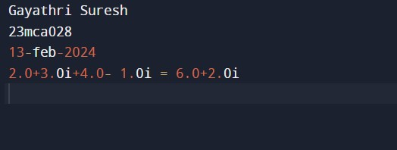

**4. Read a matrix from the console and check whether it is symmetric or not.**

## Code

import java.util.Scanner;

public class

MatrixSymmetryChecker { public static void main(String[]

args) {

System.out.println("Gayathri Suresh \n 23MCA028 \n 13-feb-2024");

Scanner input = new Scanner(System.in); System.out.print("Enter the number of rows in the matrix: "); int rows = input.nextInt();

System.out.print("Enter the number of columns in the matrix: "); int cols = input.nextInt();

int[][] matrix = new int[rows][cols];

System.out.println("Enter the elements of the matrix:");

for (int i = 0; i <

rows; i++) { for (int j = 0; j < cols; j++) {

matrix[i][j] = input.nextInt();

}

}

boolean

isSymmetric =

true; for (int i = 0; i < rows; i++) { for (int j = 0; j < cols; j++) { if (matrix[i][j] != matrix[j][i]) { isSymmetric = false; break;

} } if

(!isSymmetri c) { break;

}

}

if (isSymmetric) {

System.out.println("The matrix is symmetric.");

} else {

System.out.println("The matrix is not symmetric.");

}

}

}

## Output

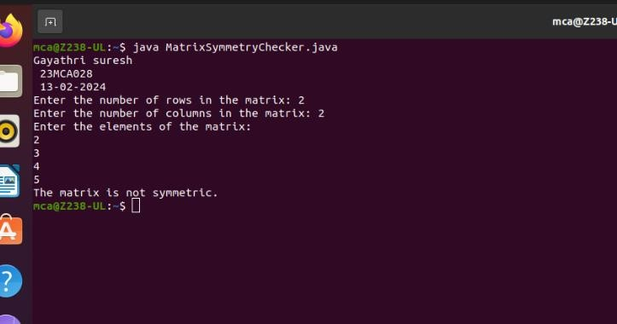

**5. Create CPU with attribute price. Create inner class Processor (no. of cores, manufacturer) and static nested class RAM (memory, manufacturer). Create an object of CPU and print information of Processor and RAM.**

## Code

public class CPU { private double price; private Processor processor; private RAM

ram;

public CPU(double price, Processor processor, RAM ram) { this.price = price; this.processor = processor; this.ram = ram;

}

public double

getPrice() { return

price;

}

public Processor

getProcessor() { return processor;

}

public RAM getRam() {

return ram;

}

public static class Processor { private int numberOfCores;

private String manufacturer;

public Processor(int numberOfCores, String manufacturer) {

this.numberOfCores = numberOfCores;

this.manufacturer = manufacturer;

}

public int

getNumberOfCores() {

return numberOfCores;

}

public String getManufacturer() { return

manufacturer;

}

}

public static class RAM { private int memory;

private String manufacturer;

public RAM(int memory, String manufacturer) { this.memory = memory; this.manufacturer =

manufacturer;

}

public int

getMemory() {

return memory;

}

public String getManufacturer() { return

manufacturer;

}

}

public static void main(String[] args) {

System.out.println("Gayathri Suresh \n 23MCA028 \n 13-feb-2024");

Processor processor = new Processor(4, "Intel");

RAM ram = new RAM(8, "Kingston");

CPU cpu = new CPU(500.0, processor, ram);

System.out.println("CPU Price: " + cpu.getPrice());

System.out.println("Processor: " + cpu.getProcessor().getManufacturer() + " " + cpu.getProcessor().getNumberOfCores() + " cores");

System.out.println("RAM: " + cpu.getRam().getManufacturer() + " " + cpu.getRam().getMemory() + " GB");

}

}

## Output

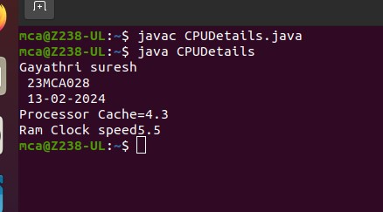

**6.** **Program to Sort strings**

import java.util.Arrays; public class StringSorter { public static void main(String[] args) {

System.out.println("Gayathri suresh\n 23mca028\n 26-feb-2024");

String[] strings = {"banana", "apple", "cherry", "date"};

System.out.println("Original array: " + Arrays.toString(strings));

Arrays.sort(strings);

System.out.println("Sorted array: " + Arrays.toString(strings));

}

}

**Output:**

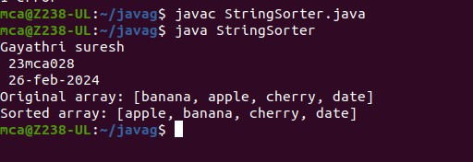

**7**. **Search an element in an array.**

public class ArraySearch { public static void main(String[] args) {

System.out.println("Gayathri suresh\n 23mca028\n 26-feb-2024");

int[] array = { 1, 5, 9, 2, 4, 7 }; int target = 4; boolean found = false;

for (int i = 0; i < array.length; i++) { if (array[i] == target) {

found = true; break;

}

}

if (found) {

System.out.println("Element " + target + " found in the array.");

} else {

System.out.println("Element " + target + " not found in the array.");

}

}

}

**Output:**

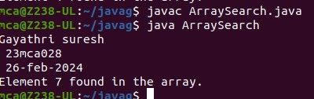

**8**. **Perform string manipulations**

import java.util.Scanner; public class String_manipulation{ public static void main(String[] args) {

System.out.println("Gayathri suresh\n 23mca028\n 26-feb-2024");

System.out.println("Enter The String");

Scanner sc = new Scanner(System.in);

String str1 = sc.nextLine();

System.out.println("Length of String = "+str1.length());

System.out.println("Character at First position = "+str1.charAt(1));

System.out.println("String Contains 'Col' sequence :"+str1.contains("Col"));

System.out.println("String ends with e : "+str1.endsWith("e"));

System.out.println("Replace'col' with 'kol' : "+str1.replaceAll("col","kol"));

System.out.println("LOWERCASE : "+str1.toLowerCase());

System.out.println("UPPERCASE : "+str1.toUpperCase());

}

}

**Output:**

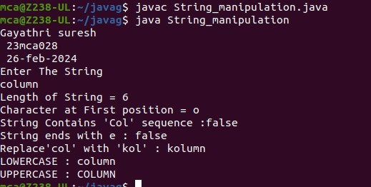

**9 .Program to create a class for Employee having attributes eNo, eName eSalary. Read n employ information and Search for an employee given eNo, using the concept of Array of Objects.**

import java.util.Scanner; public class employee { int eNo; String eName; double eSalary; public void getdetails(){

System.out.println("\nEnter the Employee details");

Scanner sc = new Scanner(System.in); System.out.println("Employee number : "); eNo=sc.nextInt();

System.out.println("Name : "); sc.nextLine(); eName=sc.nextLine();

System.out.println("Salary : "); eSalary=sc.nextDouble();

}

void display(){

System.out.println("Empolyee No :"+eNo);

System.out.println("Name :"+eName);

System.out.println("Salary Amount"+eSalary+"\n");

}

public static void main(String[] args) {

System.out.println("Gayathri suresh\n 23mca028\n 26-feb-2024");

System.out.println("\nEnter the No. of Employee's"); Scanner sc1 = new Scanner(System.in); int num = sc1.nextInt();

employee arr[]=new employee[num]; for(int i =0;i<num;i++){

arr[i]=new employee();

arr[i].getdetails();

}

System.out.println("\nInformations of all the employee's"); for(int i=0;i<num;i++){ arr[i].display();

}

boolean state = false;

System.out.println("\nEnter the Employee Number to get details of a employee"); int num2= sc1.nextInt(); for(int i=0;i<num;i++){ if(arr[i].eNo==num2){

System.out.println("\nEmployee details");

arr[i].display();

}

}

}}

**output**

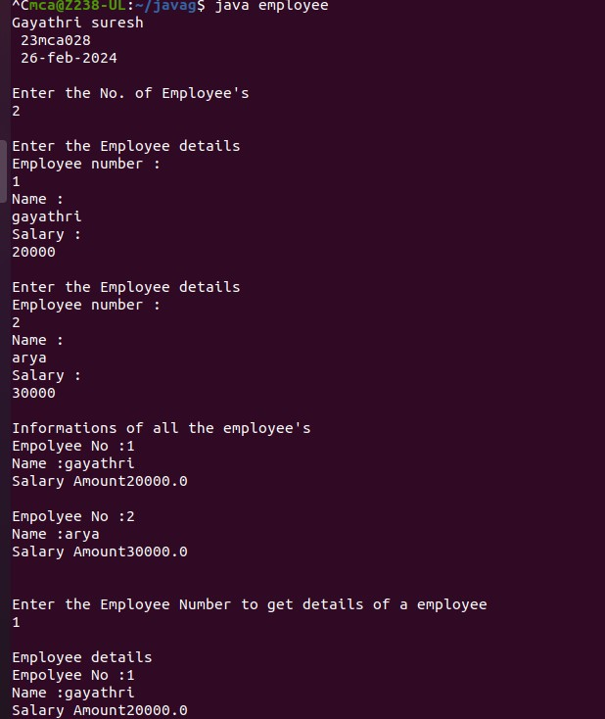

**10.** **Area of different shapes using overloaded functions**

**import java.io.*;**

**import java.util.*;**

**class Area**

**{**

**void shape(int l,int b)**

**{**

**int area;**

**area=l*b;**

**System.out.println("area of the rectangle="+area);**

**}**

**void shape(int l)**

**{**

**int area;**

**area=l*l;**

**System.out.println("area of the square="+area);**

**}**

**void shape(double r)**

**{**

**double area;**

**area=3.14*r*r;**

**System.out.println("area of the circle="+area);**

**}**

**}**

**class AreaM{**

**public static void main(String args[]){**

**Area a=new Area();**

**Scanner s=new Scanner(System.in);**

**System.out.println("Gayathri Suresh \n rollno:28 \n 2-04-2024");**

**System.out.println("enter the length and breadth of rectangle:");**

**int len=s.nextInt();**

**int bred=s.nextInt();**

**a.shape(len,bred);**

**System.out.println("enter the side of square:");**

**int side=s.nextInt();**

**a.shape(side);**

**System.out.println("enter the radius of circle:");**

**double radius=s.nextInt();**

**a.shape(radius);**

**}**

**}**

**Output**

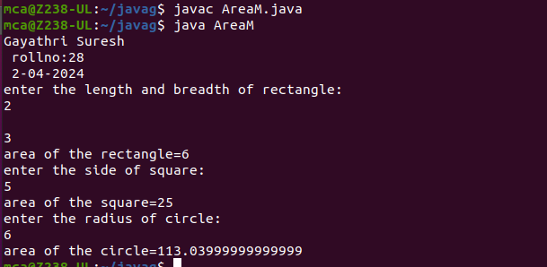

**11.** **Create a class ‘Employee’ with data members Empid, Name, Salary, Address an**

**constructors to initialize the data members. Create another class ‘Teacher’ that inherit theproperties of class employee and contain its own data members department, Subjects taught and constructors to initialize these data members and also include display function to display all the data members. Use array of objects to display details of N teachers.**

**import java.util.Scanner;**

**class Employee {**

**int Empid;**

**String Name;**

**double Salary;**

**String Address;**

**Employee(int no, String na, double sal, String add) {**

**this.Empid = no;**

**this.Name = na;**

**this.Salary = sal;**

**this.Address = add;**

**}**

**}**

**public class Teacher extends Employee{**

**String dept;**

**String subject;**

**Teacher(int no, String na, double sal, String add, String dep, String sub){**

**super(no,na,sal,add);**

**this.dept= dep;**

**this.subject=sub;**

**}**

**void display(){**

**System.out.println("Employee id: "+Empid);**

**System.out.println("Name: "+Name);**

**System.out.println("Salary: "+Salary);**

**System.out.println("Address: "+Address);**

**System.out.println("Department: "+dept);**

**System.out.println("Subject: "+subject);**

**}**

**public static void main(String[] args) {**

**System.out.println("\nEnter the No. of Employee's");**

**Scanner sc1 = new Scanner(System.in);**

**int num = sc1.nextInt();**

**Teacher arr[]=new Teacher[num];**

**for(int i =0;i<num;i++)**

**{**

**Scanner sc =new Scanner(System.in);**

**System.out.println("\nEnter Employee id: ");**

**int Empid=sc.nextInt();**

**System.out.println("\nEnter Employee Name: ");**

**String Name=sc.next();**

**System.out.println("\nEnter Salary: ");**

**double Salary=sc.nextDouble();**

**System.out.println("\nEnter Address: ");**

**String Address=sc.next();**

**System.out.println("\nEnter department: ");**

**String dept=sc.next();**

**System.out.println("\nEnter Subject: ");**

**String subject=sc.next();**

**arr[i]=new Teacher(Empid,Name,Salary,Address,dept,subject);**

**}**

**System.out.println("\n********Informations of all the employee's************");**

**for(int i=0;i<num;i++){**

**int j=i+1;**

**System.out.println("\n"+j+").");**

**arr[i].display();**

**}**

**sc1.close();**

**}**

**}**

**Output:**

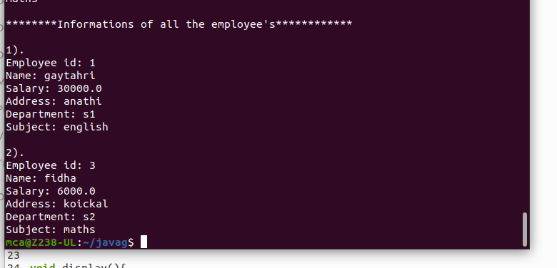

**12.Create a class ‘Person’ with data members Name, Gender, Address, Age and a constructor to initialize the data members and another class ‘Employee’ that inherits the properties ofclass Person and also contains its own data members like Empid, Company_name, Qualification, Salary and its own constructor. Create another class ‘Teacher’ that inheritsthe properties of class Employee and contains its own data members like Subject, Department, Teacherid and also contain constructors and methods to display the datamembers. Use array of objects to display details of N teachers.**

**import java.util.Scanner;**

**class person {**

**String Name;**

**String Gender;**

**String Address;**

**int Age;**

**person(String name,String gender,String address, int age) {**

**this.Name = name;**

**this.Gender = gender;**

**this.Address = address;**

**this.Age = age;**

**}**

**}**

**class Employee extends person**

**{**

**int Empid;**

**String Company_name;**

**String Qualification;**

**long Salary;**

**Employee(String name,String gender,String address, int age,int empid, String company_name, String qualification,long salary)**

**{**

**super(name,gender,address,age);**

**this.Empid= empid;**

**this.Company_name=company_name;**

**this.Qualification=qualification;**

**this.Salary=salary;**

**}**

**}**

**public class Teacher2 extends Employee{**

**String Subject;**

**String Department;**

**String Teacherid;**

**Teacher2(String name,String gender,String address, int age,int empid, String company_name, String qualification,long salary, String subject, String department, String teacherid){**

**super(name,gender,address,age,empid,company_name,qualification,salary);**

**this.Subject=subject;**

**this.Department=department;**

**this.Teacherid=teacherid;**

**}**

**void display(){**

**System.out.println("Name: "+Name);**

**System.out.println("Gender: "+Gender);**

**System.out.println("Address: "+Address);**

**System.out.println("Age: "+Age);**

**System.out.println("Employee id: "+Empid);**

**System.out.println("Company Name: "+Company_name);**

**System.out.println("Qualification: "+Qualification);**

**System.out.println("Salary: "+Salary);**

**System.out.println("Subject: "+Subject);**

**System.out.println("Department: "+Department);**

**System.out.println("Teacher id: "+Teacherid);**

**}**

**public static void main(String[] args) {**

**System.out.println("Gayathri suresh\n 23mca028\n 06-apr-2024");**

**System.out.println("\nEnter the No. of Teacher's");**

**Scanner sc1 = new Scanner(System.in);**

**int num = sc1.nextInt();**

**Teacher2 arr[]=new Teacher2[num];**

**System.out.println("\n Enter the Teacher Details\n");**

**int x = 0,j=0;**

**Scanner sc =new Scanner(System.in);**

**for(int i =0;i<num;i++)**

**{**

**x = i +1;**

**System.out.println("\n"+x+").");**

**System.out.println("\n Name: ");**

**String a =sc.next();**

**System.out.println("\n Gender: ");**

**String b =sc.next();**

**System.out.println("\n Address: ");**

**String c =sc.next();**

**System.out.println("\n Age: ");**

**int d =sc.nextInt();**

**System.out.println("\n Employee id: ");**

**int e =sc.nextInt();**

**System.out.println("\n Company name: ");**

**String f =sc.next();**

**System.out.println("\n Qualification: ");**

**String g =sc.next();**

**System.out.println("\n Salary: ");**

**long h =sc.nextLong();**

**System.out.println("\n Subject: ");**

**String k =sc.next();**

**System.out.println("\n Department: ");**

**String l =sc.next();**

**System.out.println("\n Teacher Id: ");**

**String n =sc.next();**

**arr[i]=new Teacher2(a,b,c,d,e,f,g,h,k,l,n);**

**}**

**sc.close();**

**System.out.println("\n********Informations of all the Teacher's************");**

**for(int i=0;i<num;i++){**

**j=i+1;**

**System.out.println("\n"+j+").");**

**arr[i].display();**

**}**

**sc1.close();**

**}**

**}**

**Output:**

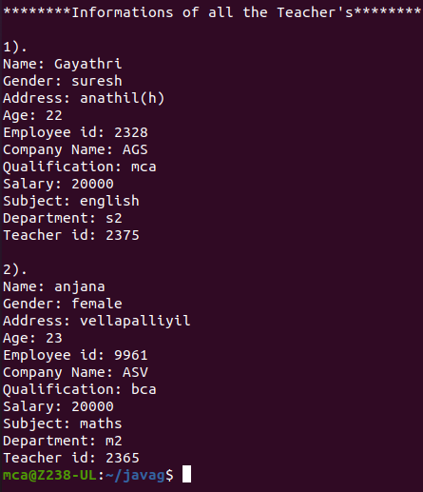

**13.** **Write a program has class Publisher, Book, Literature and Fiction. Read the information**

**and print the details of books from either the category, using inheritance.**

**import java.util.Scanner;**

**class Publisher{**

**String publisher;**

**Publisher(String pub){**

**this.publisher=pub;**

**}**

**}**

**class Book extends Publisher{**

**String book;**

**Book(String pub,String boo){**

**super(pub);**

**book=boo;**

**}**

**}**

**class Literature extends Book{**

**String category;**

**Literature(String pub, String boo){**

**super(pub, boo);**

**}**

**void display(){**

**System.out.println("Publisher :"+publisher);**

**System.out.println("Book :"+book);**

**}**

**}**

**class Fiction extends Book{**

**Fiction(String pub, String boo){**

**super(pub, boo);**

**}**

**void display(){**

**System.out.println("Publisher :"+publisher);**

**System.out.println("Book :"+book);**

**}**

**}**

**public class bookDetails{**

**public static void main(String[] args) {**

**System.out.println("Gayathri suresh\n 23mca028\n 06-apr-2024");**

**System.out.println("\nEnter the No. of Literature Books");**

**Scanner sc1 = new Scanner(System.in);**

**int num = sc1.nextInt();**

**Literature arr[]=new Literature[num];**

**System.out.println("\n Enter the Literature Book Details\n");**

**int x = 0,j=0;**

**Scanner sc =new Scanner(System.in);**

**for(int i =0;i<num;i++)**

**{**

**x = i +1;**

**System.out.println("\n"+x+").");**

**System.out.println("\n Book : ");**

**String boo =sc.next();**

**System.out.println("\n Publisher: ");**

**String pub =sc.next();**

**arr[i]=new Literature(pub,boo);**

**}**

**System.out.println("\nEnter the No. of Fiction Books");**

**int num1 = sc1.nextInt();**

**Fiction arr1[]=new Fiction[num1];**

**System.out.println("\n Enter the Fiction Book Details\n");**

**int x1 = 0,j1=0;**

**for(int i =0;i<num1;i++)**

**{**

**x1 = i +1;**

**System.out.println("\n"+x1+").");**

**System.out.println("\n Book : ");**

**String boo =sc.next();**

**System.out.println("\n Publisher: ");**

**String pub =sc.next();**

**arr1[i]=new Fiction(pub,boo);**

**}**

**sc.close();**

**sc1.close();**

**System.out.println("\n********Informations of all the Literature Books************");**

**for(int i=0;i<num;i++){**

**j=i+1;**

**System.out.println("\n"+j+").");**

**arr[i].display();**

**}**

**System.out.println("\n********Informations of all the Fiction Books************");**

**for(int i=0;i<num1;i++){**

**j1=i+1;**

**System.out.println("\n"+j1+").");**

**arr1[i].display();**

**}**

**sc1.close();**

**}**

**}**

**output**

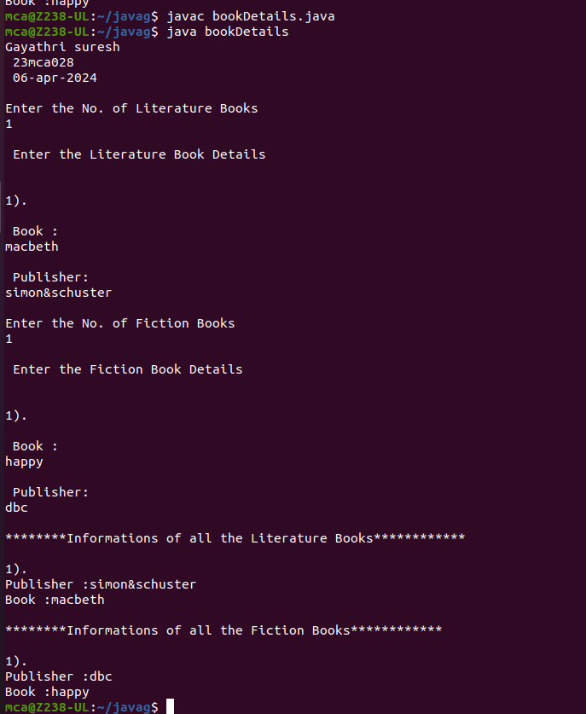

**14.** **Create classes Student and Sports. Create another class Result inherited from Student and Sports. Display the academic and sports score of a student.**

**import java.util.Scanner;**

**class sports{**

**String sport;**

**int Rating;**

**sports(String spo, int ra){**

**sport = spo;**

**Rating = ra;**

**}**

**}**

**class student extends sports{**

**String Grade;**

**double Overall_per;**

**student(String spo, int ra,String gd, double per ){**

**super(spo, ra);**

**Grade = gd;**

**Overall_per = per;**

**}**

**}**

**public class result extends student {**

**result(String spo, int ra,String gd, double per ){**

**super(spo, ra, gd, per);**

**}**

**void display(){**

**System.out.println("\nSports Details of Student");**

**System.out.println("Sport :"+sport);**

**System.out.println("Rating :"+Rating);**

**System.out.println("\nAcademic Details of Student");**

**System.out.println("Academic Grade :"+Grade);**

**System.out.println("Overall percentage :"+Overall_per);**

**}**

**public static void main(String[] args) {**

**System.out.println("Gayathri suresh\n 23mca028\n 06-apr-2024");**

**Scanner sc =new Scanner(System.in);**

**System.out.println("\nEnter the Sports Details of Student");**

**System.out.println("\n Sport: ");**

**String a =sc.next();**

**System.out.println("\n Sport Rating out** **of 10: ");**

**int b =sc.nextInt();**

**System.out.println("\nEnter the Sports Details of Student");**

**System.out.println("\n Academic Grade: ");**

**String c =sc.next();**

**System.out.println("\n Overall percentage: ");**

**double d =sc.nextDouble();**

**sc.close();**

**result obj= new result(a,b,c,d);**

**obj.display();**

**}**

**}**

**output**

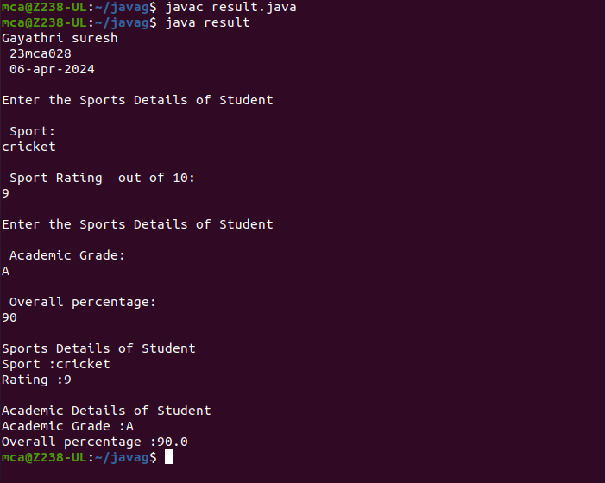

**15.** **Create an interface having prototypes of functions area() and perimeter(). Create two**

**classes Circle and Rectangle which implements the above interface. Create a menu driven**

**program to find area and perimeter of objects.**

**import java.util.Scanner;**

**interface prop**

**{**

**void getdata();**

**void area();**

**void perimeter();**

**}**

**class Circle implements prop**

**{**

**double pi = 3.14;**

**double r;**

**Scanner sc = new Scanner(System.in);**

**@Override**

**public void getdata()**

**{**

**System.out.println("Enter the radius of the circle:");**

**r = sc.nextDouble();**

**}**

**@Override**

**public void perimeter()**

**{**

**System.out.println("Perimeter of the circle: "+(2*pi*r));**

**}**

**@Override**

**public void area()**

**{**

**System.out.println("Perimeter of the circle: "+(pi*r*r));**

**}**

**}**

**class Rectangle implements prop**

**{**

**double l,b;**

**Scanner sc = new Scanner(System.in);**

**@Override**

**public void getdata()**

**{**

**System.out.println("Enter the length of the rectangle:");**

**l = sc.nextDouble();**

**System.out.println("Enter the breadth of the rectangle:");**

**b = sc.nextDouble();**

**}**

**@Override**

**public void area()**

**{**

**System.out.println("Perimeter of a rectangle: "+(l*b));**

**}**

**@Override**

**public void perimeter()**

**{**

**System.out.println("Perimeter of a rectangle: "+(2*(l+b)));**

**}**

**}**

**public class shape6**

**{**

**public static void main(String[] args)**

**{**

**System.out.println("Gayathri suresh\n 23mca028\n 08-apr-2024");**

**int ch;**

**Scanner sc = new Scanner(System.in);**

**Circle ob = new Circle();**

**Rectangle obj = new Rectangle();**

**do**

**{**

**System.out.println("\n1.Circle\n2.Rectangle\n3.exit");**

**System.out.println("Enter your choice:");**

**ch = sc.nextInt();**

**switch(ch)**

**{**

**case 1 :ob.getdata();**

**ob.area();**

**ob.perimeter();**

**break;**

**case 2 :obj.getdata();**

**obj.area();**

**obj.perimeter();**

**break;**

**case 3 :System.out.println("Exited...");**

**System.exit(0);**

**}**

**}while(true);**

**}**

**}**

**Output**

